**Shaping Volcanoes**

**Aim:** To find out if the composition of volcanoes affects the angle of repose.

**Hypothesis:** _____________________________________________________________________________

**Variables:**   
 Independent _____________________________

Dependent _____________________________

Controlled _______________________________________________________

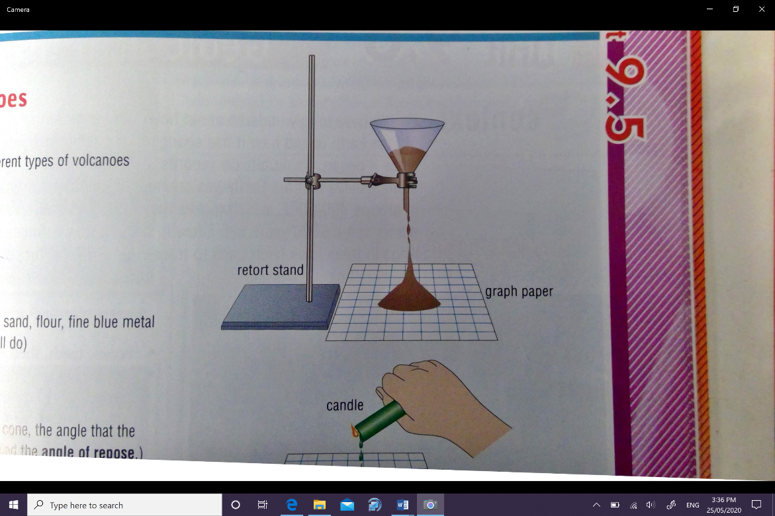

**Materials:**

* Funnel
* Retort stand
* Boss head and clamp
* Graph paper
* Ruler
* Sand
* Flour
* Iron filings
* Protractor
* Calculator

Figure 1

**Method:**

1. Set up the funnel and retort stand as shown in diagram 1 above.
2. Place your finger over the bottom end of the funnel and fill it with sand.
3. Remove your finger and let the sand run out.
4. Measure the height of the sand mound created on the graph paper.
5. Use the graph paper to estimate the diameter of its base.
6. Calculate its radius.
7. Construct a scale diagram of the side-view (cross-section) of the mound.
8. Use a protractor to measure the angle that the sand makes with the horizontal (the angle of repose).
9. Put the angle on your diagram (see figure 2 below).
10. Repeat steps 2-9 for the other samples of flour and iron filings.

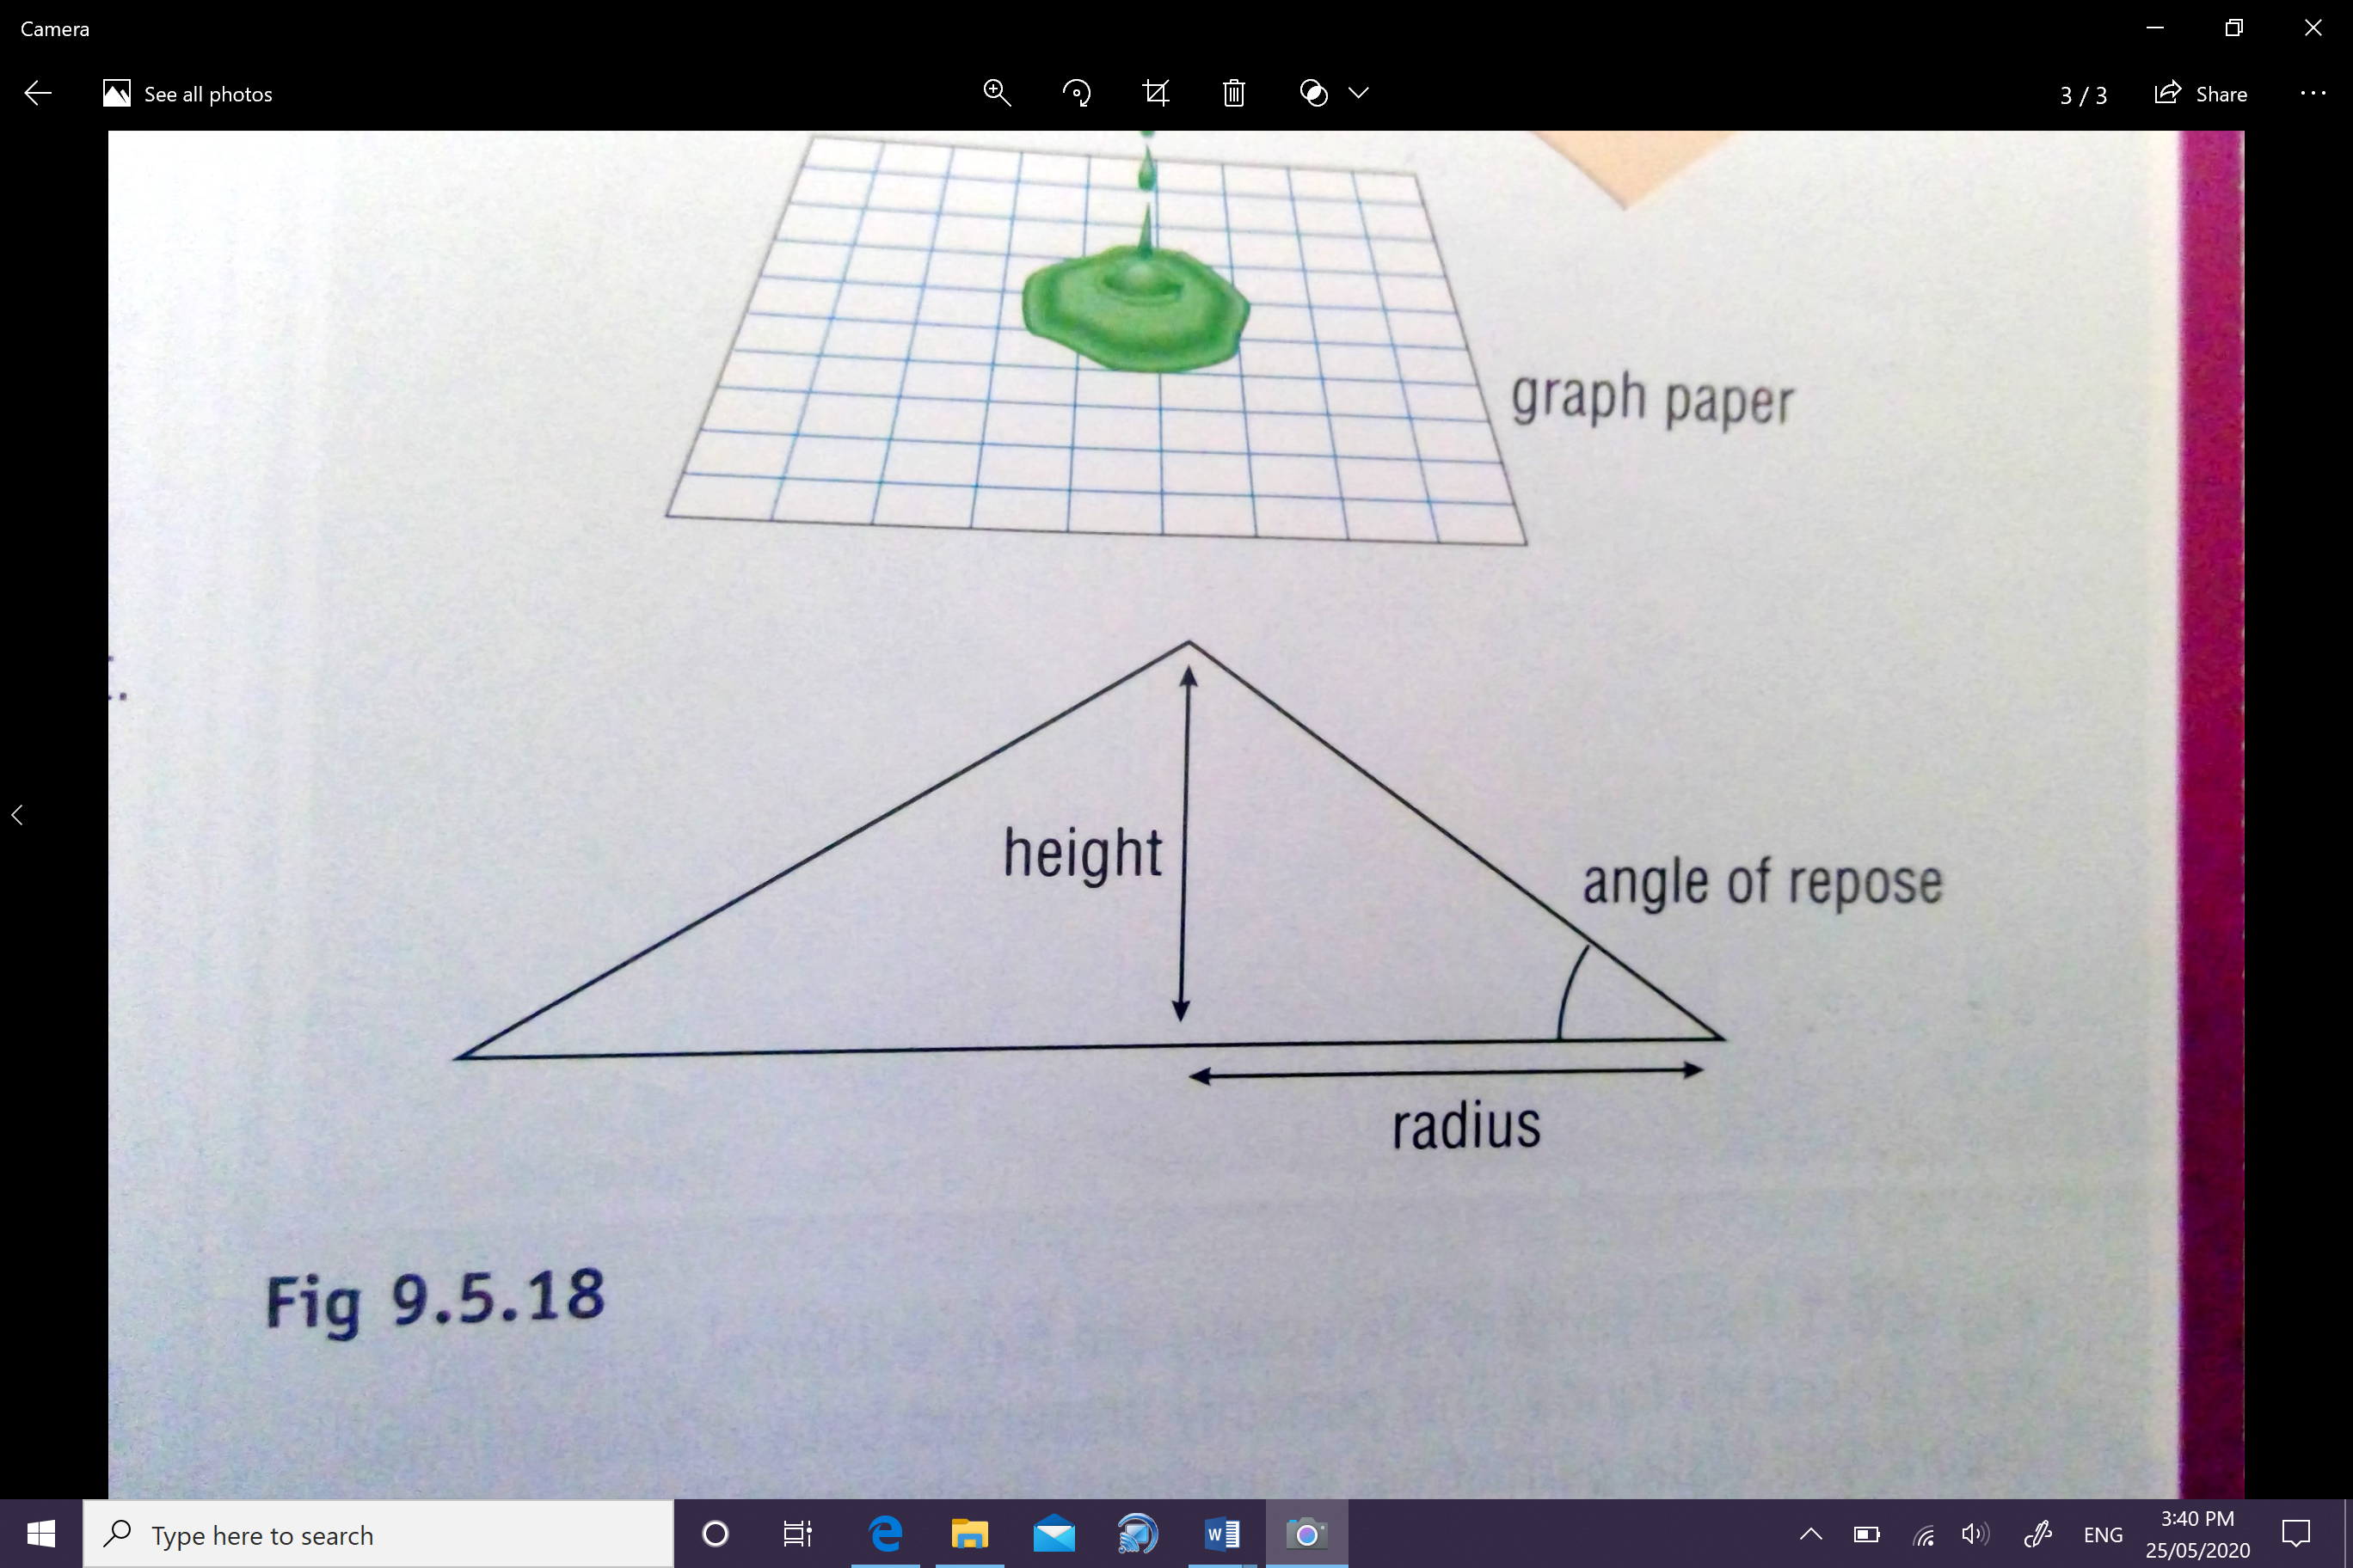

Figure 2

**Results:**

|  |  |  |  |  |  |  |
| --- | --- | --- | --- | --- | --- | --- |
| **Material** | **Height (cm)** | **Diameter (cm)** | **Radius (cm)** | **Circumference (cm)** | **Angle of Repose (°)** | **Diagram** |
| Sand |  |  |  |  |  |  |
| Flour |  |  |  |  |  |  |
| Iron Filings |  |  |  |  |  |  |

1. Arrange the materials in order from smallest to largest angle of repose. ______________________________________________________________________________________________________________________________________________________
2. Assess why the angles might differ between the materials. _________________________________________________________________________________________________________________________________________________________________________________________________________________________________
3. Suggest whether bigger volcanoes have different angles to smaller volcanoes of the same material. _________________________________________________________________________________________________________________________________________________________________________________________________________________________________

**Discussion:**

1. Do the results of this experiment support the hypothesis? Use the data obtained to support your answer. ____________________________________________________________________________________________________________________________________________________________________________________________________________________________________________________________________________________________________________
2. How does this experiment simulate the formation of volcanoes? _________________________________________________________________________________________________________________________________________________________________________________________________________________________________

___________________________________________________________________________

**Conclusion:**

Does the composition of volcanoes affect their angle of repose? ______________________________________________________________________________________________________________________________________________________

**Evaluation:**

1. Suggest one error that may have occurred during this experiment. ______________________________________________________________________________________________________________________________________________________
2. Did this error affect the accuracy of your results? ______________________________________________________________________________________________________________________________________________________
3. How could this error be avoided, to increase the reliability of the experiment? ______________________________________________________________________________________________________________________________________________________